My Hero
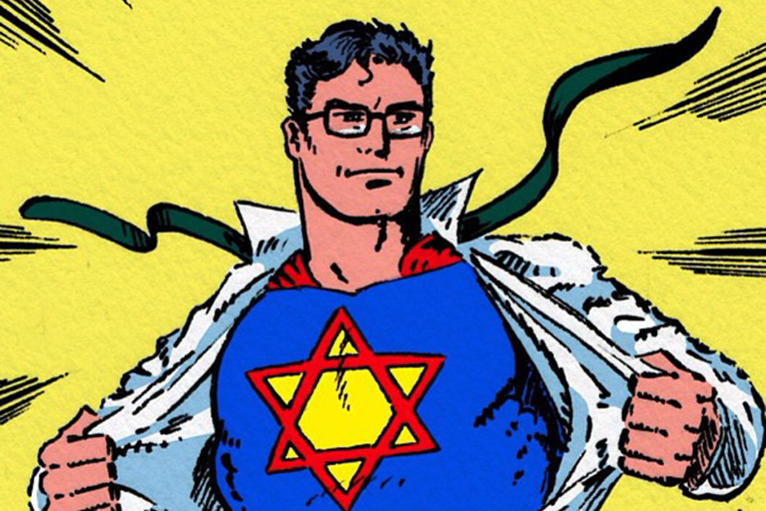

#1
Questions:
- List 2 people you would call your heroes.
- Why do you call each of these people your heroes?
- Fill in the name of your heroes at the top of each column and check off the traits that each hero has:

 | Hero #1 | Hero #2
Are your heroes ↓
Cool
Wealthy
Quiet
Loud
Strong
Funny
Smart
Courageous
Attractive
Tough
Generous
Thoughtful
Famous

#2
Cambridge Dictionary
Hero Worship
A feeling of extreme admiration for someone, imagining that they have qualities or abilities that are better than anyone else's.

Question: What is your view on hero worship?
Rabbi S.R. Hirsch on Torah
Our sages… never objected to drawing attention to the small and big mistakes and weaknesses in the history of our great forefathers, thereby making them all the more instructive for us ...

Questions:
How ideal should a hero be?
What are the pros and cons of having heroes?

#3
Fox News Flash, June 20, 2019
Hero 9/11 first responder and retired NYPD Detective Luis Alvarez gave his last-ever interview on "Shepard Smith Reporting" Thursday, to plead with federal lawmakers to replenish the 9/11 victims fund.
Alvarez discovered he was going into liver failure after finishing his 69th round of chemotherapy on Wednesday and used his final interview to advocate on behalf of the victims and their families.
"I'm doing well. I'm comfortable. I'm not in a lot of pain. I have my family surrounding me and I'm at peace," Alvarez told Smith. He also said he has no regrets and was simply doing his job on the day of the attacks.
"I have no regrets -- no regrets whatsoever," he said. "9/11 happened. We got called down. It's my job as an NYPD detective to respond to emergencies. So, no hesitation. We went down, spent about three months down there doing the bucket brigade, doing rooftop detail, trying to find remains. I did what every other FDNY, NYPD, EMS worker -- everybody. I'm nobody special. I did what all the other guys did. And now we're paying the price for it."

Question: Fox News calls NYPD Detective Luis Alvarez a hero. Shouldn't a true hero do something very unusual, something neither he nor anyone else typically does, as Luis Alvarez suggests himself?

Medrash Rabbah
Rabbi Levi: There are two times that “Lech Lecha” - "Go out" - is written in the Torah and we do not know which is G-d’s favorite – the first or the second. The first “Lech Lecha” is Torah Bereshis 12:1: “Go out from your land, from your birthplace, and from your father’s house to the land that I will show you.” The second “Lech Lecha” is in connection with the Binding of Yitzchak, where Avraham is told “Go out to the Land of Moriah and offer him there as a burnt offering on one of the mountains I will tell you.” Torah Bereshis 22:2.
Rabbi Levi concludes that the Binding of Yitzchak was a greater test than the test of Avraham leaving his homeland and thus the second instance of “Lech Lecha” is “more precious to G-d”.

Question: Why would anyone think that the test of leaving one’s homeland (particularly in the context of the great reward that G-d promised to Avraham if he complied with this commandment) might be comparable to the test of the Binding of Yitzchak? The Binding of Yitzchak would be the most difficult for any parent – particularly such a person as Avraham, who was the paradigm of kindness and who had preached monotheism and the virtues of a Merciful G-d all these years to his many disciples?!

What does this comparison between seemingly incomparable tests teach us about the hero Avraham and about heroism in general?

#4
Tana D'vei Eliyahu ch.25
One is obligated to say, 'When will my deeds reach the deeds of my forefathers, Avraham, Yitzchak and Yaakov?'

Questions:
- We know that it is humanly impossible to reach the lofty levels of our forefathers - why then are we told to strive for something out of reach?
- Does identifying your hero suggest that you know what kind of person you want to become?
- In which way would you want to be like your heroes?
- Is there any way you would not want to be like your heroes?

#5
Laws of Idol Worship, Rambam (Maimonides) 1:3
… Though [Avraham] was a child, he began to think throughout the day and night, wondering: How is it possible for the sphere to continue to revolve without having anyone controlling it? Who is causing it to revolve? Surely, it does not cause itself to revolve … When he recognized and knew Him, he began to formulate replies to the inhabitants of Ur Kasdim and debate with them, telling them that they were not following a proper path.
He broke their idols and began to teach the people that it is fitting to serve only the G-d of the world. To Him alone is it fitting to bow down, sacrifice, and offer libations, so that the people of the future generations would recognize Him. Conversely, it is fitting to destroy and break all the images, lest all the people err concerning them, like those people who thought that there are no other gods besides these images.
When he overcame them through the strength of his arguments, the king desired to kill him. He was saved through a miracle and left for Charan. There, he began to call in a loud voice to all people and inform them that there is one God in the entire world, and it is proper to serve Him. He would go out and call to the people, gathering them in city after city and country after country, until he came to the land of Canaan (Land of Israel)- proclaiming G-d's existence the entire time] - as [Torah Bereishis 21:33] states: "And He called there in the name of the Lord, the eternal G-d."

Questions: Is there anything you would stand up for, no matter what, because it is right, even though you may suffer for it?

#6
Question: What’s your takeaway from today’s discussion?

